Lab 4 - Command Line Operation (August 24, 2026)
Name: Qimin Zhu ID: 6888143
Paste captured screenshots of the results for each question.
- Accessing directory: http://linuxfoundation.s3-website-us-east-1.amazonaws.com/TIY/usingcd/index.html

- Hard link
  - Create a text file fileA.txt containing a few lines of text by running this command:
for i in {1..10}; do echo "Hello Linux $i"; done > fileA.txt
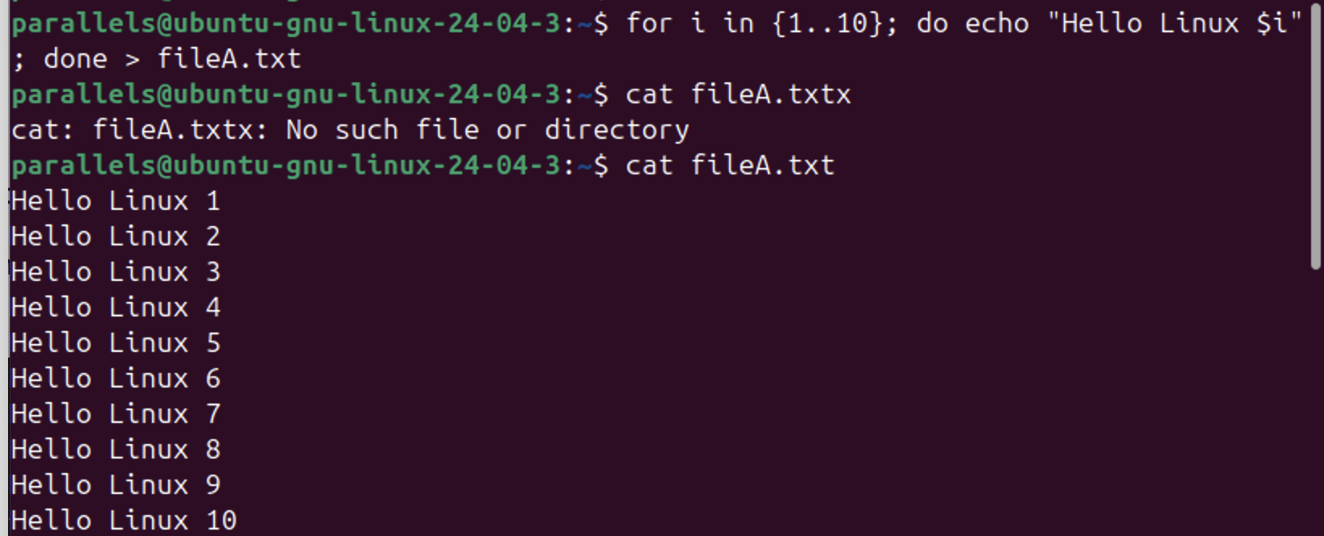
  - Create a hard link fileB.txt to link to fileA.txt. List both files.
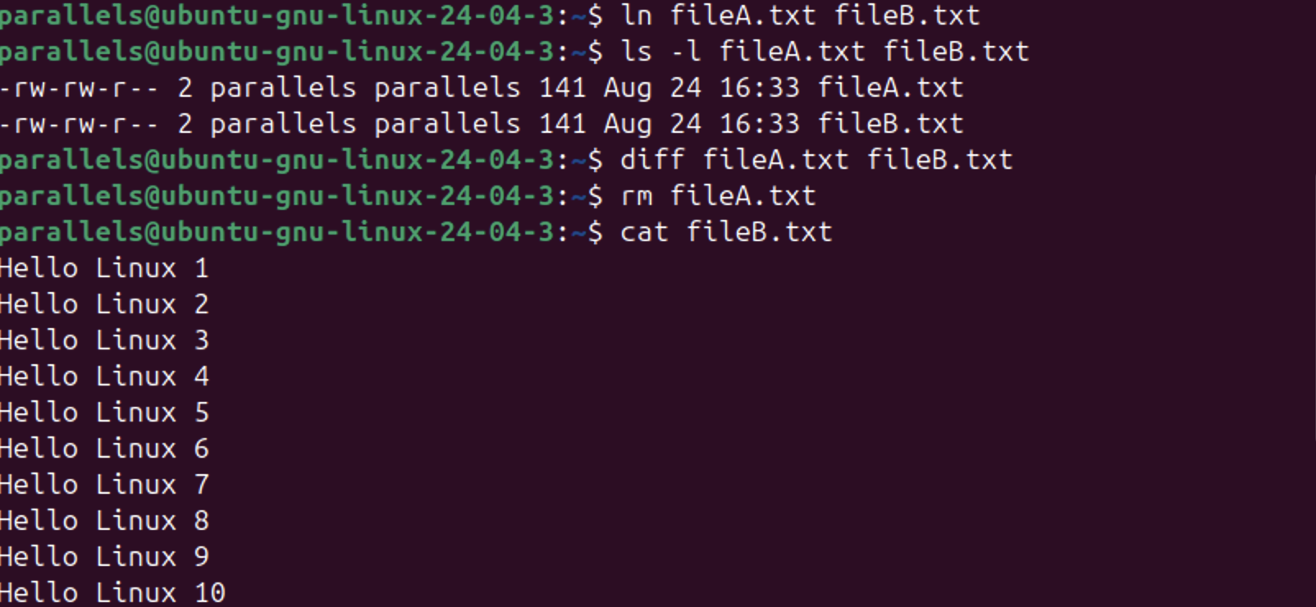
  - Show contents of fileA.txt and fileB.txt
  - Delete fileA.txt and show content of fileB.txt
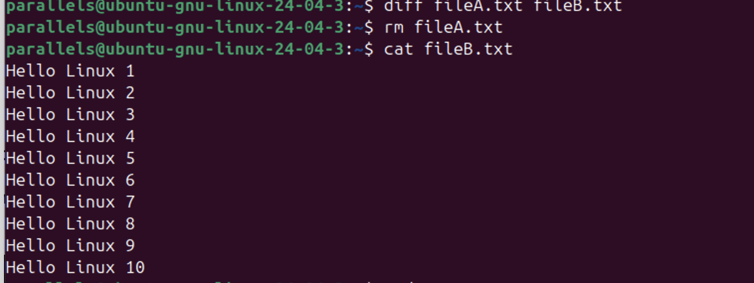
  - Create a soft link as fileC.txt file to link to fileB.txt 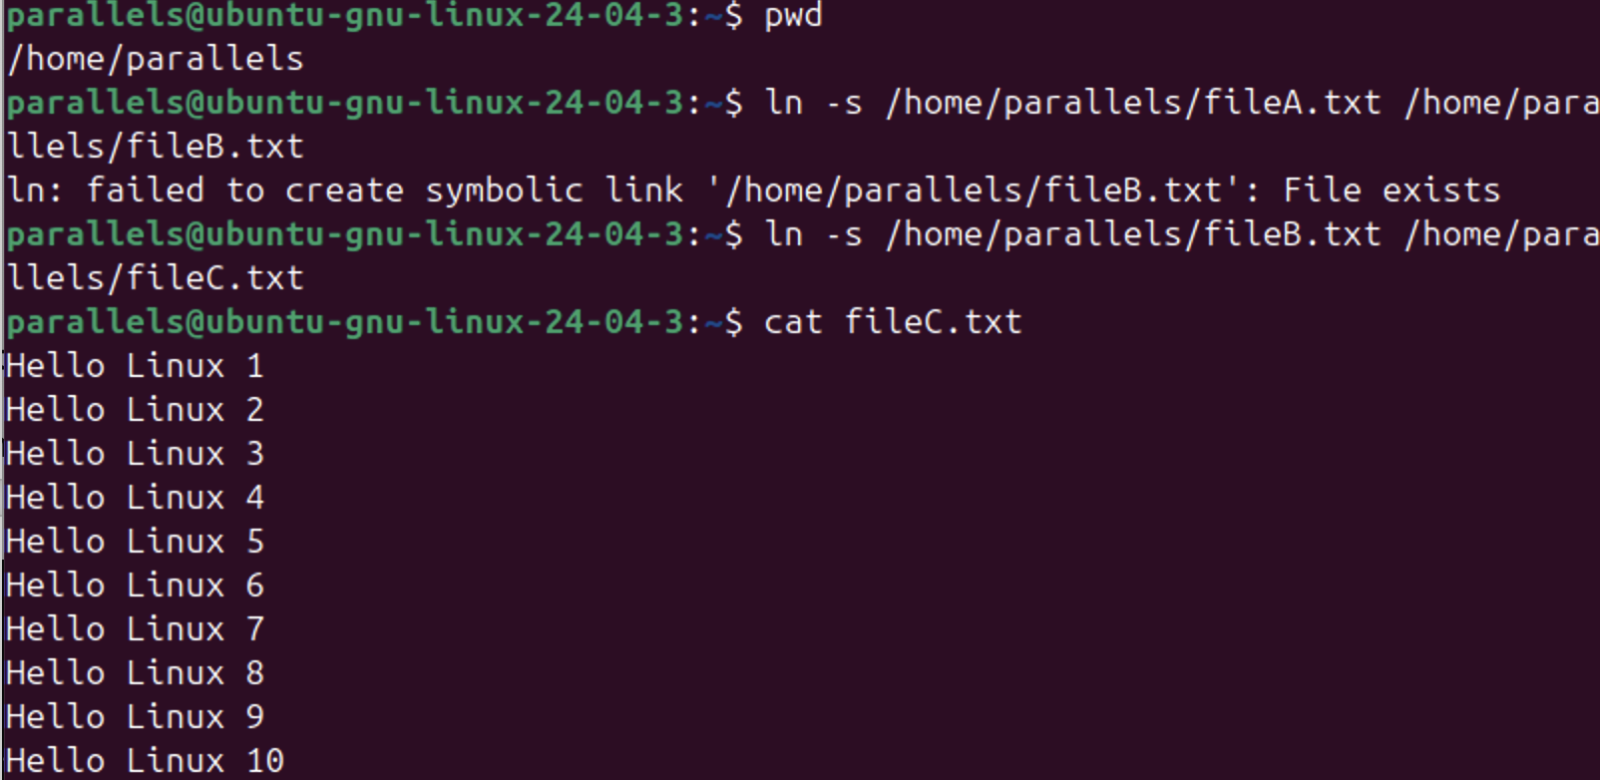

  - Delete fileB.txt and show content of fileC.txt
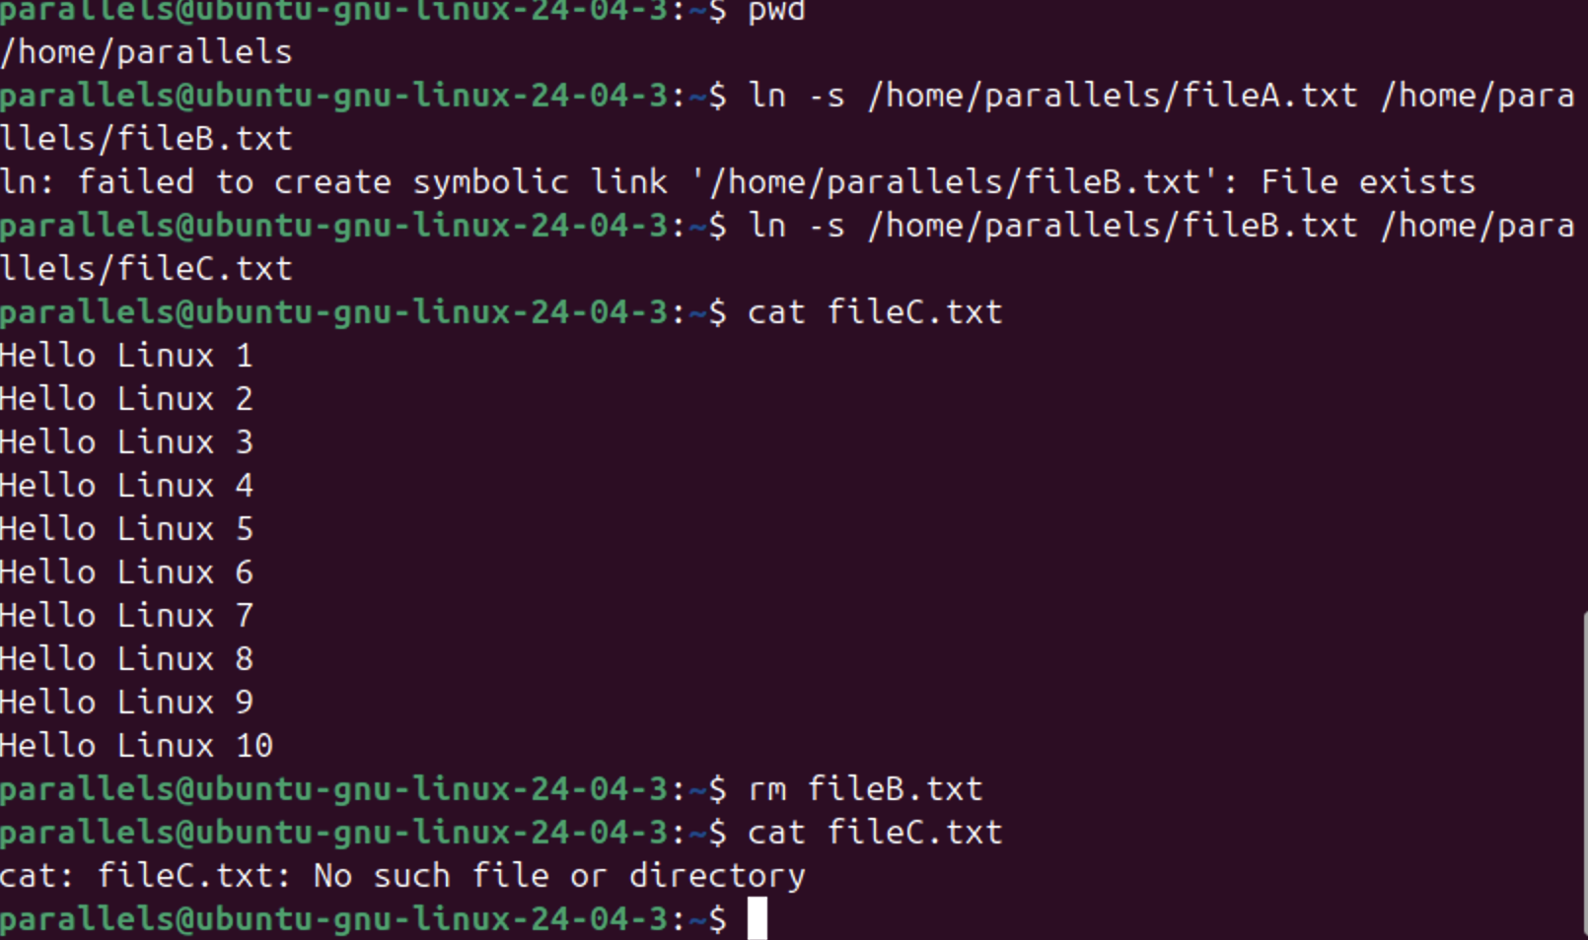

- Find the init.d directory, starting from /, and then create a symbolic link from within your home directory to this directory.
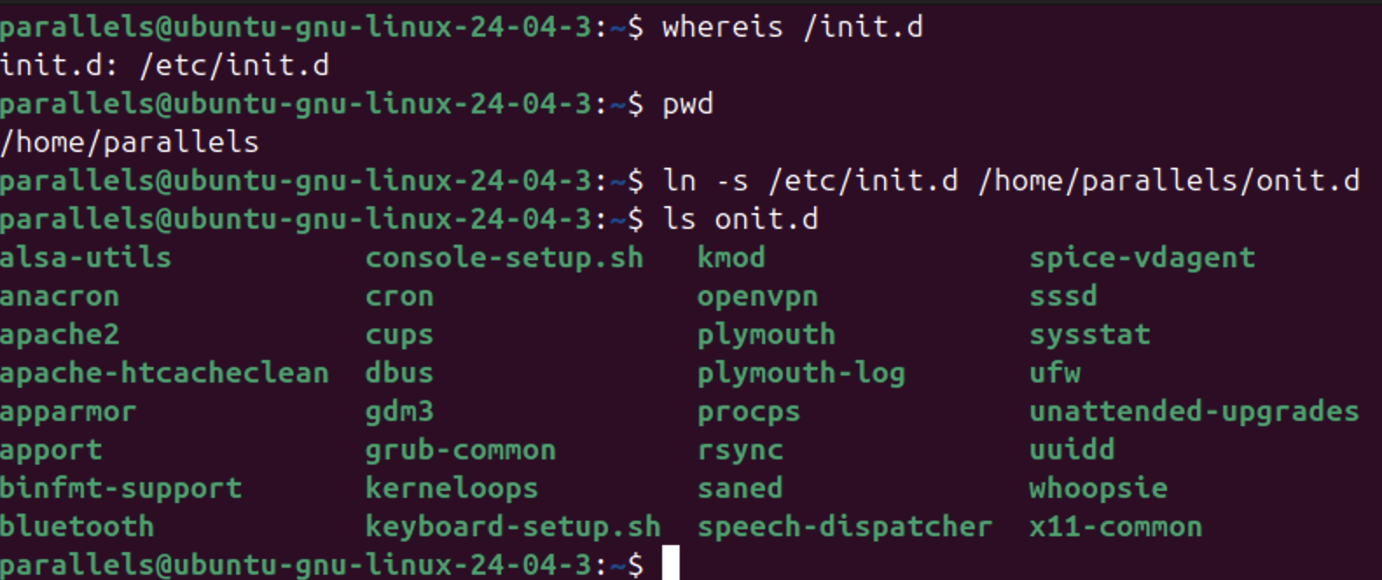

- Create sample.txt containing 200 lines of any text by using this command:
for i in {1..200}; do echo "test$i"; done > random_text.txt
- Use cat command to view the file in each page
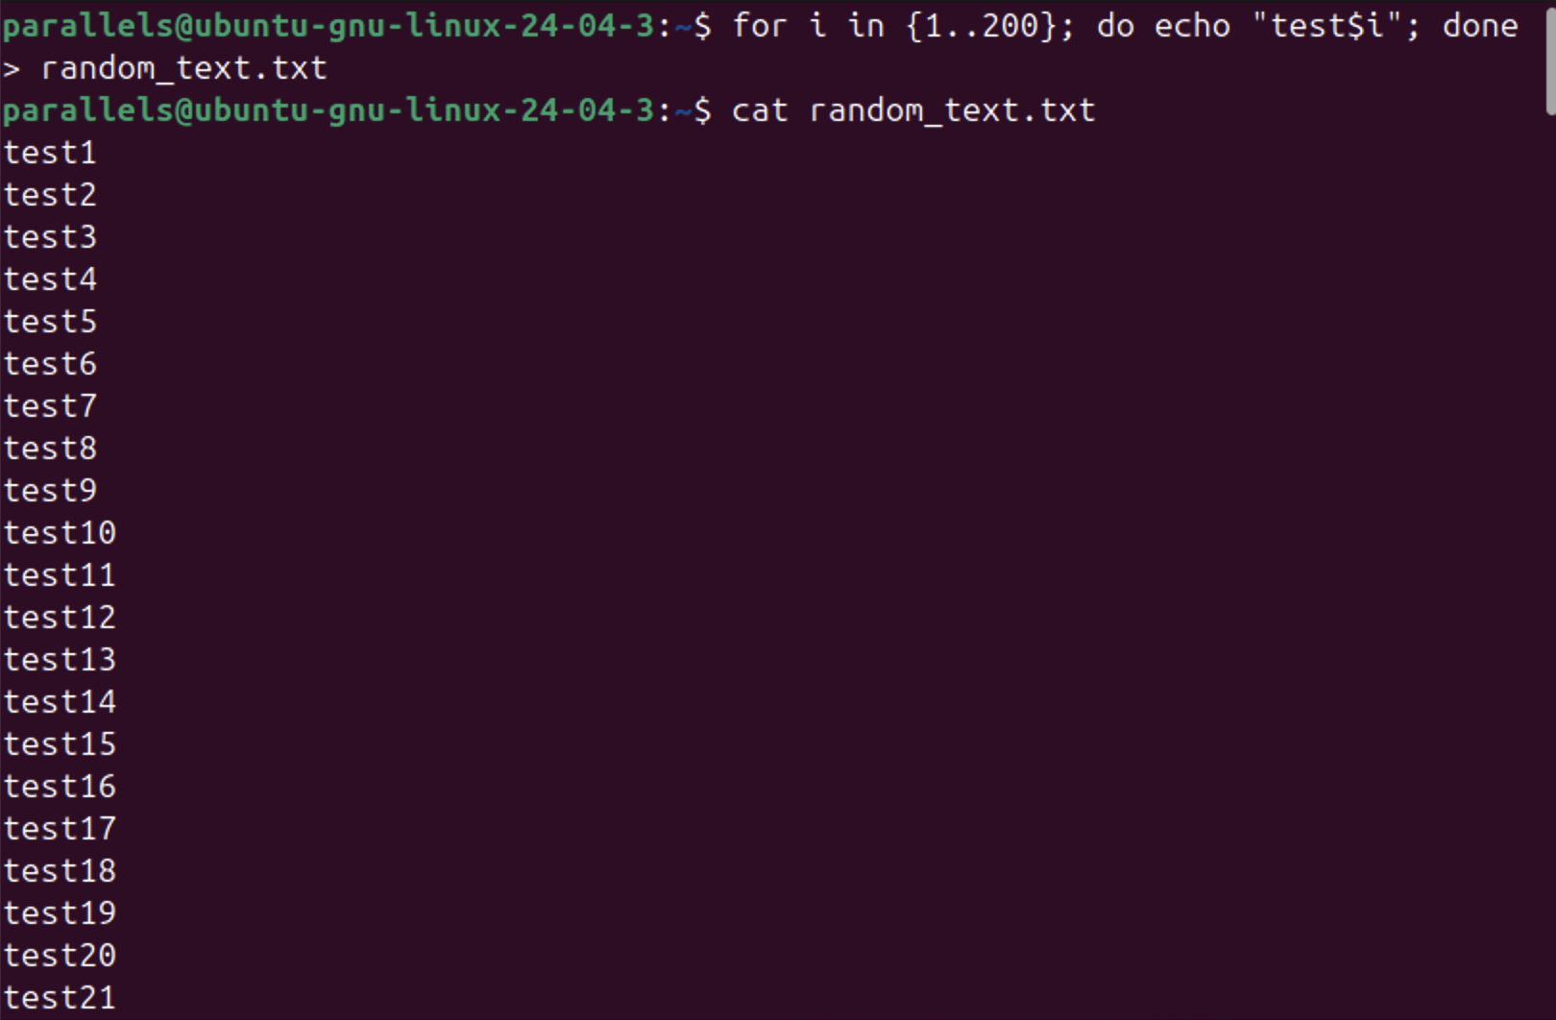
- Use cat command to view the file with the line numbers
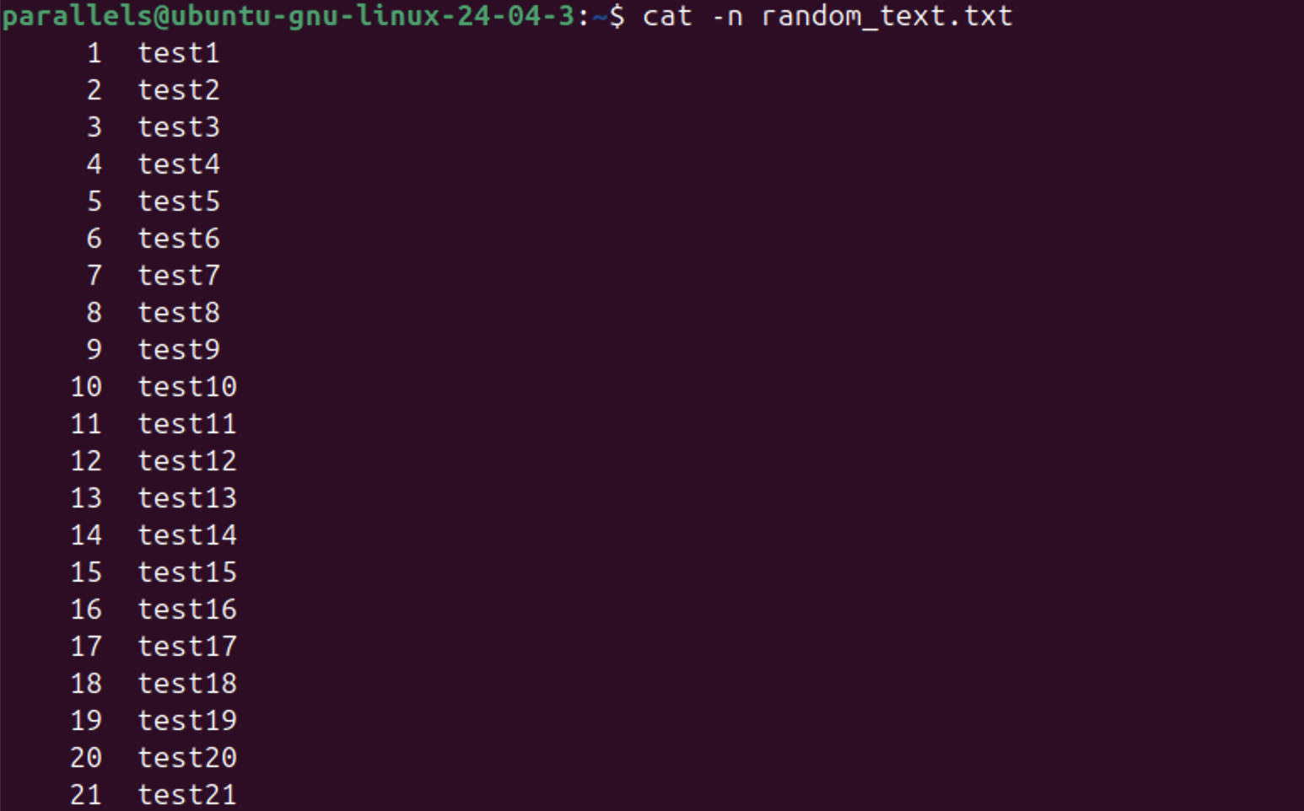
- Use less command to view the file with the line numbers
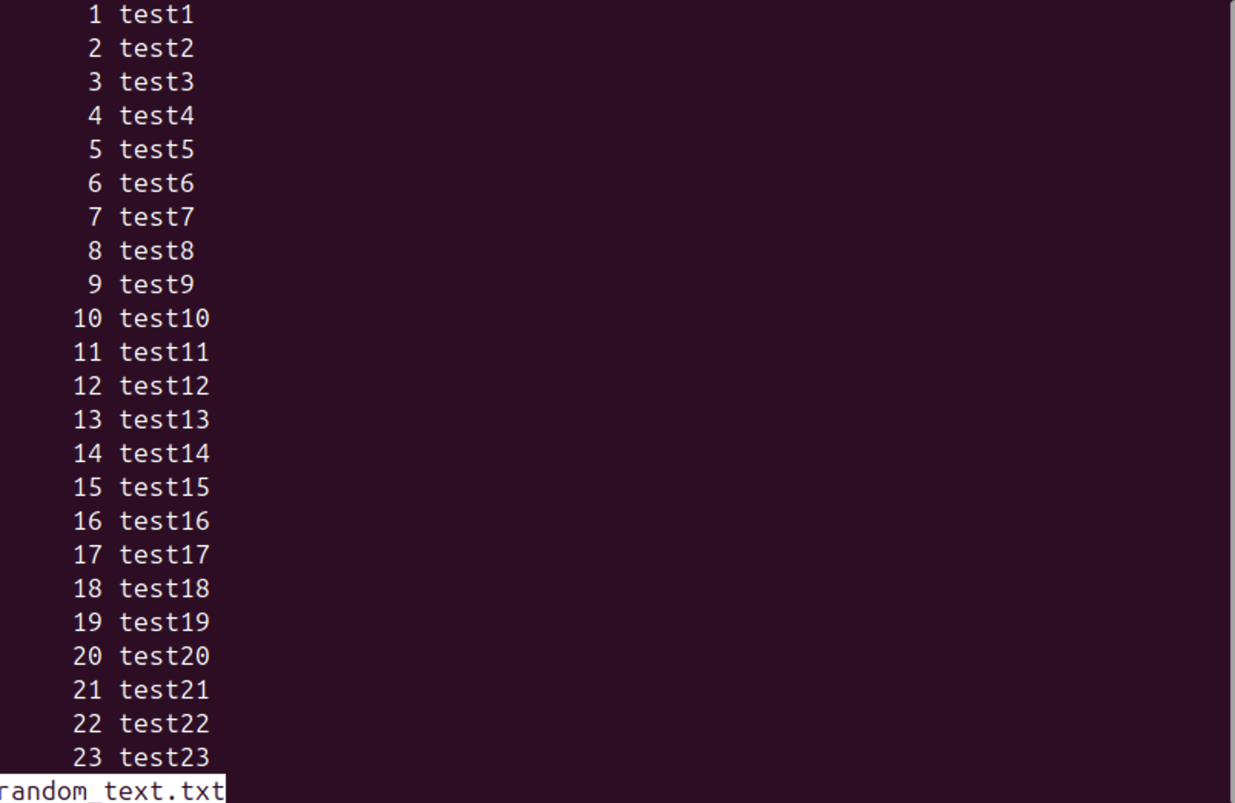
- View content from the last line to the first line
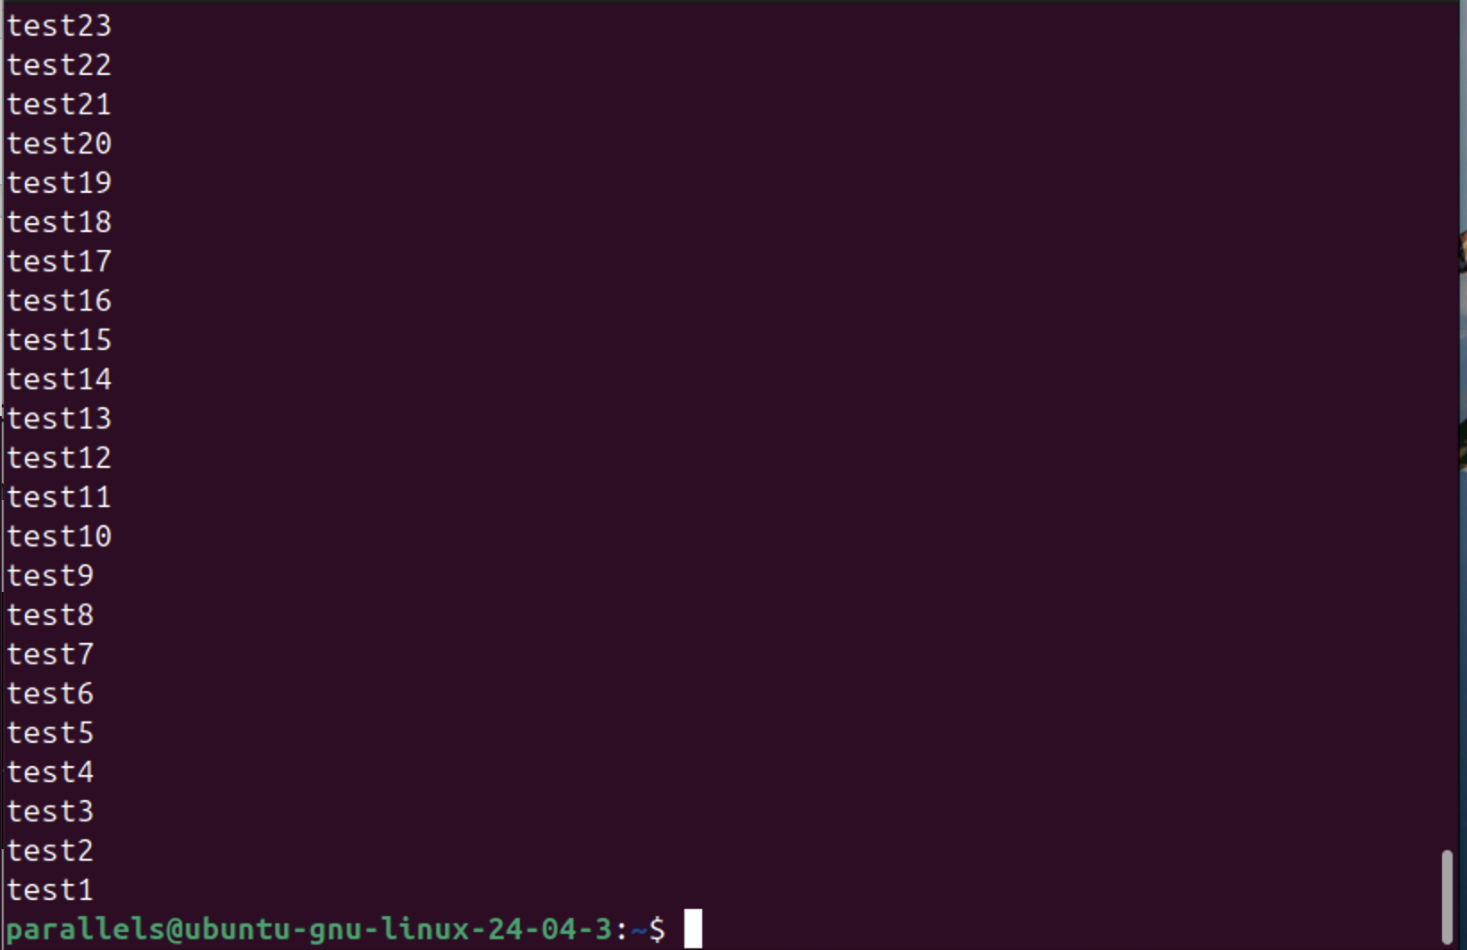
- View first 5 lines of the file
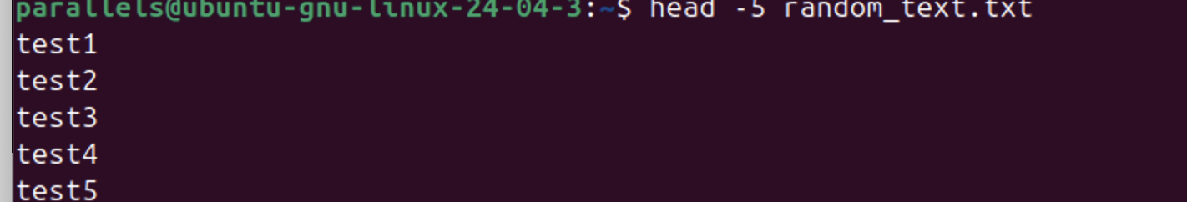
- View last 5 lines of the file
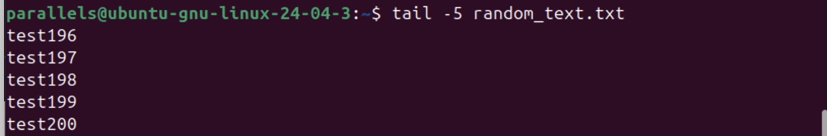

- Working with files and directories
  - Create file1 and file2 (two empty files) in the home directory
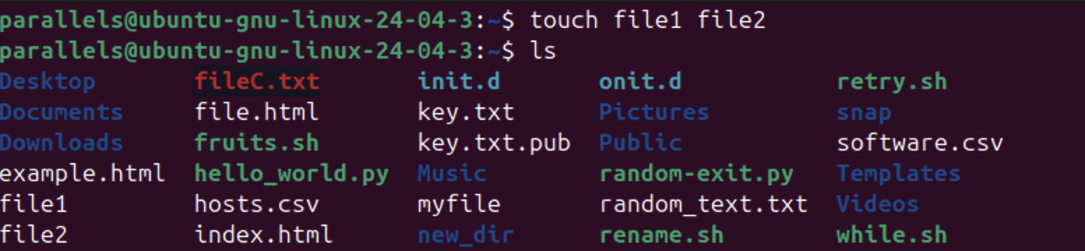
  - Check for the existence of file1 and file2.
  - Rename file1 to new_file1.
  - Create a directory named dir1.
  - Move new_file1 and file2 files to dir1 directory.
  - Remove new_file1 using rm without any options.
  - Remove dir1 and its content.
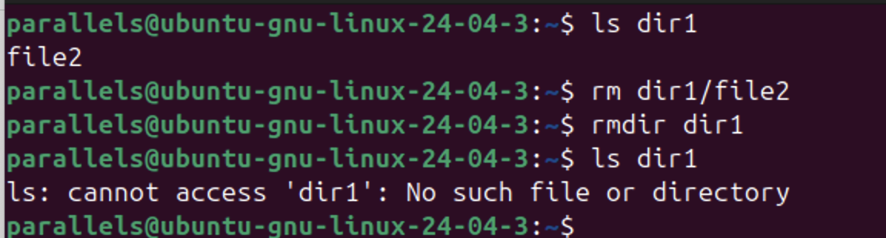

- Create an empty file named exercise.txt and move this file to the /tmp directory, using a relative pathname from your home directory. Then, delete this file using an absolute pathname.
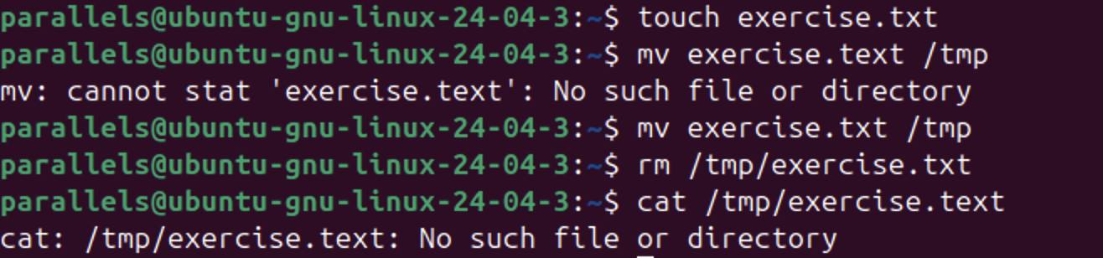

- Locating files: http://linuxfoundation.s3-website-us-east-1.amazonaws.com/TIY/usinglocate/index.html

- Using wildcards with ls: http://linuxfoundation.s3-website-us-east-1.amazonaws.com/TIY/usinglswildcards/index.html

